15.78: a) Consider the derivation of the speed of a longitudinal wave in Section 16.2. Instead of the bulk modulus B, the quantity of interest is the change in force per fractional length change. The force constant 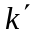 is the change in force force per length change, so the force change per fractional length change is 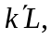 the applied force at one end is 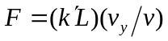 and the longitudinal impulse when this force is applied for a time t is 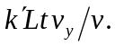 The change in longitudinal momentum is 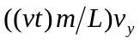 and equating the expressions, canceling a factor of t and solving for 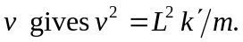

An equivalent method is to use the result of Problem 11.82(a), which relates the force constant and the “Young’s modulus” of the Slinky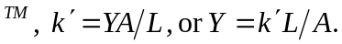 The mass density is 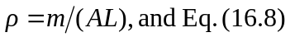 gives the result immediately.

b)

